

Project Appraisal Memorandum

Project Finance

PT. Lie Fung

PT. Lie Fung

Corporate Credit Facility amounting to USD 35 millions consisting of USD 5 millions Working Capital Facility and USD 30 millions Senior Term Loan Facility.

GIAA-GMF093-01AISF

19-December-2018

Table of Contents

Part I - Dashboard 3

A. Project 3

B. Borrower 5

C. Proposal 5

D. Recommendation 9

Part II – Project Analysis 11

Part III – Historical Financial & Financial Projection 13

Part IV – Supplemental, Procurement and Insurance 15

Part V – Social and Environmental Assessment/IIF’s Principles 18

Part VI - Attachment 20

A. Group Structure 20

B. Term Sheet 21

C. Risk rating 23

D. KYC Checklists 26

E. Other Banks Facilities / Summary of Pefindo report 28

F. Industry Analysis 31

G. Legal Due Diligence Report 32

H. S&E Due Diligence 32

I. Other Reports 32

# Part I - Dashboard

## Project

|  |  |
| --- | --- |
| Project Description | This document will be the baseline in later phases for subsequent development activities. |
| Sector – Sub Sector | AIRPORT - AIRPORT SUPPORTING FACILITIES |
| Project Cost | USD 900,000.00 |
| Project Scope | Cash Deficiency Support Facility  As a common occurrence in newly operating toll road, cash deficiency will likely to occur within the first few years of operations as traffic from revenue will be unable to cover operating expense, interest expense and principal payment. In this case, based on our financial projection, under the base case scenario, ABC is assumed to require cash deficiency support of IDR 800 billion for the first two years of operation and additional IDR 1.6 trillion in the next 9 years. |
| Project Structure | ABC is the BUJT/ Toll Road Concession Holder of ABC Toll Road. ABC was established on 15 June 2006 and is the concession holder of ABC for up to 40 years (until 2057).    On 22 February 2016, DEF through XYZ, as per the direction of Minister of State Owned Enterprise was asked to participate in accelerating the development and construction of Trans Java toll road projects and thus, DEF completed the acquisition of 60% ownership of ABC from the previous shareholders. The remainder 40% is still owned by SMJ. Both DEF and SMJ are existing clients of IIF with good account conduct.    XYZ was incorporated in June 2014 and is the subsidiary of PT DEF (Persero) Tbk, a major state-owned construction company. Currently, XYZ is the owner of 18 toll road concessions with over 1,000 km in length. On February 2017, XYZ welcomed state-owned infrastructure financing company PT Sarana Multi Infrastruktur (SMI) and state-owned pension insurance firm PT Taspen as its shareholders through PINA (Non State Funding Mechanism) by Bappenas. This highlights synergy between State Owned Enterprises (SOEs) and government’s intention in accelerating infrastructure projects.    **SMJ** is the founding company of the **Mitra Jaya Group**(“MJG”)**.** MJG is wholly owned by Mr. Sumitra Gowindasamy (Indonesian Citizen). Based on Globe Asia magazine in June 2016, he is the 92nd richest person in Indonesia with total net worth of USD 430mn. Beside construction and mining business, he has since diversified into palm oil plantations, crude palm oil mill, the packaging industry and ink production.    As of end of June 2018, the project has reached 99% completion with regards to land acquisition and construction progress on average has reached over 80%. The Project was functional starting 8 June 2018 for Idul Fitri holiday.    ABC entered into EPC Contract with DEF for the procurement of construction work Pemalang – Batang toll road package I, II and IV on 31 March 2016 and entered into EPC Contract with SMJ for the procurement of construction work Pemalang – Batang toll road package III on the same day. |
| Deal Strategy | We intend to replace the existing short term loan of DEF with a Senior Loan and a Cash Deficiency Support Facility (“CDS”) in ABC.    It is common for toll road projects to have cash deficiency during first years of operation as traffic needs to ramp up before it can generate enough revenues to cover the costs of operation and payments of principals and interests.    We propose for IIF to participate in the Cash Deficiency Support Facility due to the following reasons:  1. To participate in providing funding of an infrastructure project that is part of Trans Java Toll Road and listed in Acceleration of National Strategic Project;    2. To participate in projects with acceptable risk/reward profile. From risk perspective, although the project is greenfield in nature, we are coming to the project at the time when risks can be considered as minimal. With regards to land acquisition, as of end of June 2018, 99% of total land required has been acquired. Construction progress on average has reached over 80% and the Project is functional (can temporarily be used) starting 8 June 2018 for Idul Fitri holiday only. In addition, ABC is located in a densely populated Central Java and the interconnectivity of toll roads in TransJava toll road will likely to increase traffic volume to ABC;  From return/ reward perspective, comparable return with equity and pari passu collateral, funding and strategic support from Government of Indonesia through Bappenas and strength of sponsors also provide additional comforts for the Project.  While the CDS Facility has 17 year tenor, we view the Facility as quasi equity with acceptable return (13.5% return versus valuation using CAPM with ranges of 13.9% - 14.9%. We also view that given the recent trend of toll road divestment at 1.5x – 2x of project cost, divesting its shares in ABC or its shares in other toll road projects within XYZ will provide reassurance that XYZ will generate enough cash to cover its cash flow needs in the next few years.    3. To continue our support for existing clients by providing project based loan and deepening our relationship with major player in infrastructure sector - XYZ and DEF;    4. To perform our role as a catalyst in the infrastructure financing sector by providing financing type that traditional banks are not able to provide while at the same time making sound judgement in investment.  * Notes: BOD IC has approved for IIF to participate in the new Senior Term Loan BNI Sindikasi II for ABC in the amount of IDR 200 billion and currently in the final documentation stage. Signing of the Senior Term Loan BNI Sindikasi II is expected on mid August 2018. |

## Borrower

|  |  |  |  |  |
| --- | --- | --- | --- | --- |
| Project Company | PT Garuda Maintenance Facility | | | |
| Project Sponsors | |  |  |  | | --- | --- | --- | | Project Company | Project Sponsors | % ownership | | PT. Lie Fung | PT. Lie | 50.00 | | PT. Lie Fung | PT. Fung | 40.00 | | | | |
| Ultimate Beneficial Owner | Lie Fung | | | |
| Rating | IIF Rating | External Rating | S&E Category | LQC/BI Checking |
| IIF6  Rating Date: 19 Dec 2018 | S&P: AA+  Moodys: Aa2  Fitch: AA+  Pefindo: idAA | B-II | 2 - Special Mention / Dalam Perhatian Khusus |
| Other Information | Based on the assessment, we recommend for IIF to participate in the Cash Deficiency Support Facility of IDR [600] billion with 17.5 year tenor and to approve the new terms and conditions set out in the proposed Indicative Term Sheets. | | | |

## Proposal

|  |  |  |
| --- | --- | --- |
| Purpose | **National Strategic Projects (First Arterial Road Serving the Area)**  Since the issuance of the Presidential Regulation No. 3/2016 re: the acceleration in the implementation of national strategic projects with Trans Java toll roads included in the list of projects, 500 kms of Trans Java toll roads has been constructed, 180 kms had reached commercial operation and 260 kms was functional (temporarily in operation) starting on 8 June 2018 for Idul Fitri holiday. Of the 1,162 kms total length of Trans Java toll road, over 1,000kms will reach commercial operation by end of 2018, a testament to the significant impact of acceleration.    For Pemalang-Batang, the construction of ABC Toll Road marks the presence of an arterial road or arterial thoroughfare which is a public road that serves major transportation vehicles with long-haul traits, high average speeds, and a limited number of access roads at the highest level of service possible. Other than the over congested Pantura, there was no arterial road presence in ABC prior to ABC project.          **PINA (Non State Funding Mechanism) by Bappenas**  On the financing side, the government provides its support through National Development Planning Board (Bappenas) by introducing PINA mechanism. PINA (Pembiayaan Investasi Non APBN or Non State Funding) intended to speed up financing for infrastructure development, complements existing schemes for private-public partnerships (PPPs), such as viability gap funds (VGF) and availability payment (AP). On February 2017, through PINA mechanism, state-owned infrastructure financing company PT Sarana Multi Infrastruktur (SMI) and state-owned pension insurance firm PT Taspen had distributed early equity of Rp 3.5 trillion, bringing total equity to Rp 9.5 trillion of the Rp 16 trillion needed.  Under the PINA scheme, cash from pension funds, for instance, will be channeled into an intermediary, which will later issue bonds. Proceeds from bond sales will be used to buy equity in companies executing infrastructure projects. Once the infrastructure becomes operational, the intermediary will sell the equity.    **LMAN for Land Acquisition**  Land acquisition is a significant hurdle faced by the Indonesian authorities in infrastructure development. To overcome to this hurdle, the Government established LMAN. Lembaga Manajemen Aset Negara (“LMAN”) / State Asset Management Agency was established on 16 December 2015 by the House of Representatives as a public service agency under the Finance Ministry’s Directorate General of State Assets. It has been tasked to assist with the heavy task of procuring land required - by funding and the utilization of land banks as well as pay compensation for land acquisition to support the government’s infrastructure development programs.    The presence of LMAN is supposed to speed the process of land procurement and ease the financing burden due to its quicker turnaround. The government allocated the agency state capital worth Rp 16 trillion (US$1.2 billion) and Rp 20 trillion in the 2016 and 2017 state budgets, respectively. | |
| Approval Authority | BOC-IC | |
| Facility | |  |  | | --- | --- | | Type | Amount | | Senior Term Loan | USD 700,000.00 | | Remarks : Please note that our investment thesis will only take into account PTAR’s existing Jamu projects and one new ongoing Pettarani Jamu Project which expected to commence in 2020. Other growth contributed by other projects will be upside to our investment. | | | |
| Group Exposure | USD 50,000.00 | |
| Remarks | ABC will incorporate IIF mandatory clauses and Corrective Action Plan of the Project in separate side letter to be signed by IIF and ABC. We have been in discussion with the Borrower and a draft of the side letter has been presented to ABC for their review.    The side letter will include statement from ABC that they will be in compliance with:  Corrective Action Plans for Social and Environmental;  IIF’s Principles;  IIF’s Procurement procedure;    ABC will also ensure that they will not be involved/ participate in Sanctionable Practices (either directly or indirectly). | |
| Tenor | 6 year(s) 2 month(s) | |
| Average Loan Life | 3 year(s) 1 month(s) | |
| Pricing | Interest Rate | Amounting to annual interest rate of Syndication Credit Facility (”**Syndication Interest Rate**”) + 3% (three percent) p.a.    Syndication Interest Rateequals to Reference rate (LPS) + 4.25% p.a.    Payment of the Interest Rate shall be paid with the followings conditions:    a. During Grace Period:  - Interest rate at[3% (three percent)] p.a shall be paid during the Grace Period; and  - Interest Rate at unpaid Syndication Interest Rate will be [compounded or capitalized[AJT1] ] which will be calculated using Syndication Interest Rate + 3% (three percent) p.a (”**Accumulated Syndication Interest Rate**”) and shall be paid by Borrower after the Grace Period.  b. After Grace Period:  - Syndication Interest Rate + 3% (three percent) per annum, added with the payment of Accumulated Syndication Interest Rate in pro-rata. |
| Commitment Fee | [1]% p.a. of the undrawn Facility Amount. Commitment fee is calculated based on daily average of undrawn portion during Availability Period.  Commitment Fee shall be paid monthly at the end of each month during Availability Period, at the latest 5 (five) Business Days after the end of each month. |
| Facility/Upfront Fee | [1]% flat of the Facility Amount, payable at 5 (five) Business Days after the Signing Date, or at the initial drawdown date, whichever is the earlier. |
| Structuring Fee | Cross collateral with the collateral for Senior Lender. Additionally, the collateral is pari passu with Lender to be elaborated further in the Security Sharing Agreement, which includes:  1. Toll Road Concession Rights based on the Toll Concession Agreement of ABC, which irrevocable power of attorney to the Lender to appoint third parties as a toll road operator;  2. All operational invoices and revenues from the operation of the toll road (other ventures pertaining to the Project) to be secured |
| Arranger Fee | ABC will incorporate IIF mandatory clauses and Corrective Action Plan of the Project in separate side letter to be signed by IIF and ABC. We have been in discussion with the Borrower and a draft of the side letter has been presented to ABC for their review.  The side letter will include statement from ABC that they will be in compliance with:  Corrective Action Plans for Social and Environmental;  IIF’s Principles;  IIF’s Procurement procedure;  ABC will also ensure that they will not be in |
| Collateral | Cross collateral with the collateral for Senior Lender. Additionally, the collateral is pari passu with Lender to be elaborated further in the Security Sharing Agreement, which includes:    1. Toll Road Concession Rightsbased on the Toll Concession Agreement of ABC, which irrevocable power of attorney to the Lender to appoint third parties as a toll road operator;  2. All operational invoices and revenues from the operation of the toll road (other ventures pertaining to the Project) to be secured with fiduciary over receivables;  3. Pledge of Borrower’s accounts and its related Power of Attorney, including but not limited to Revenue Account, Debt Service Reserve Account, Debt Service Account, Operational Account, and Excess Cash Account (“**Project Account**”);  4. Proceeds from Insurance Claims, to be secured with fiduciary over proceeds of insurance claim;  5. Proceeds of bank guarantee claim to be secured with fiduciary over proceeds of bank guarantee claim;  6. Corporate Guarantee from PT Sumber Mitra Jaya;  7. Corporate Guarantee from PT XYZ;  8. Pledged of ABC shares owned by sponsors along with power of attorney to vote and power attorney to sale shares;    (Collectively referred to as the ”**Security Document**”).    [Note: In addition to the above, the shareholders of ABC (joint and severally) agree to provide cash deficiency support, cost overrun and to maintain positive equity in a term of notarial deed of shareholders general meeting. In the notarial deed of shareholders general meeting, shareholders also provide assurance that the interest payment and principal repayment schedule are being kept on time until full repayment of the Facility.] | |
| Other Conditions | 1. The average purchase price is not higher than IDR 250 per shares  2. IIF obtaining the signed side letter from PTAR which includes:  a. PTAR’s confirmation on the compliance to IIF’s S&E principles and Corrective Action Plan;  b. IIF to have the right of first refusal to finance PTAR’s future projects; - ***Best Effort***  3. The availability of Put and Call Option agreements with acceptable party(ies) for downside protection.  4. IIF will have agreement with the existing management to have prior discussion with IIF for any strategic decision and quarterly update on Company’s business.  IIF Participation in the Phase 2 (through Right Issue) will be subject to further BOD-IC’s discretion and approval | |
| Exception to IIF Policy | Growth Strategy  In the future, PTAR will always try to expand its infrastructure Kunyit Asemfolio via organic growth and non-organic growth.The completion of of Pettarani Jamu in 2020, which is an alternative solution for traffic congestion in Makassar, followed by the rebased tariff for Class-I only, will bring meaningful growth to the Company.    In acquiring Jamu business, PTAR/MFF can be very carefull especially in selecting the asset location. The existing 4 (four) operating assets is located in inner city of Jakarta and Makassar which areas have very good and sustain traffic and provide vital role for the city. Over the last three years, the traffic was seen steadily increase with 4-year CAGR around 1.7 % for BSD Jamu, 7.9% for BMN Harbour Road, 5.2% for JTSE airKunyit Asem Jamu, and 18.3% for JLB JORR W1 for year 2012-2016. | |
| Review Period | Annual | |

## Recommendation

Key Investment Consideration

Key Investment Considerations[MAH1]

§ **Participate in providing funding of an infrastructure project that is part of Trans Java Toll Road and listed in Acceleration of National Strategic Project**

We are financing the Project which is considered key for the Government’s initiatives in rolling out the toll road infrastructure across Indonesia. The operational schedule of the Project has been accelerated by the Government.

§ **A project with acceptable risk/ reward profile**

Although the project is greenfield in nature, we are coming to the project at the time when risks can be considered as minimal. With regards to land acquisition, as of end of June 2018, 99% of total land required has been acquired. Construction progress on average has reached over 80% and the Project was functional starting 8 June 2018 for Idul Fitri holiday. In addition, ABC is located in a densely populated Central Java and the interconnectivity of toll roads in TransJava toll road will likely to increase traffic volume to ABC. As the first and only arterial road in Pemalang, ABC is well positioned to get traffic.

While the CDS Facility has 17 year tenor, we view the Facility as quasi equity with acceptable return (13.5% return versus valuation using CAPM with ranges of 13.9% - 14.9%. We also view that given the recent trend of toll road divestment at 1.5x – 2x of project cost, divesting its shares in ABC or its shares in other toll road projects within XYZ will provide reassurance that XYZ will generate enough cash to cover its cash flow needs in the next few years.

Pari passu collateral, funding and strategic support from Government of Indonesia through Bappenas and strength of sponsors also provide additional comforts for the Project.

§ **Continue our support for existing clients and major players in infrastructure sector by providing project based loan**

By providing facilities to ABC, we continue our support to DEF through XYZ and Sumber Mitra Jaya who have been our client since 2016 and 2017 respectively.

§ **Performing IIF role as a catalyst - Cash Deficiency Support Facility**

By providing a product not readily available in the market, CDS, we help ABC to become more bankable and allow IIF perform its role as a catalyst in the infrastructure financing sector by providing financing type that traditional banks are not able to provide while at the same time making sound judgement in investment.

Recommendation

Based on the assessment, we recommend for IIF to participate in the Cash Deficiency Support Facility of IDR [600] billion with 17.5 year tenor and to approve the new terms and conditions set out in the proposed Indicative Term Sheets.

|  |  |  |
| --- | --- | --- |
| Account Responsible | Deal Team | CIO |
| |  | | --- | | Anton Benyamin Simatupang | | Artisan Kunta Bahari | |  | | Hilda Savitri |

# Part II – Project Analysis

PROJECT ANALYSIS

## Master User Setting

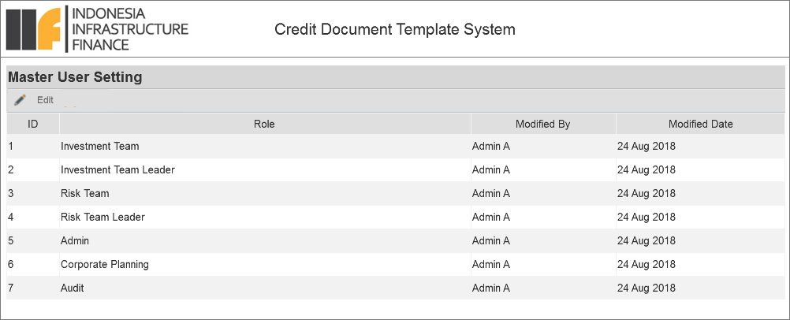

User setting is used to register users who involve in the PAM and CM document creation process. As default, there are defined groups in CDTS Application:

1. Investment Team
2. Investment Team Leader
3. Risk Team
4. Risk Team Leader
5. Corporate Planning
6. Audit
7. Admin

### Edit User in a Group

Admin can add or edit user in a group and even remove user(s) in a group.

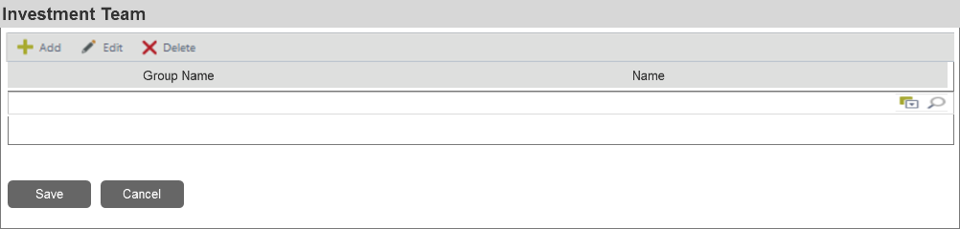

|  |  |  |  |  |
| --- | --- | --- | --- | --- |
| Field Name | Field Type (length) | Mandatory? | Default Value | Remarks |
| Add | Link Button | No | - | To add new user (member) into the group. When this button is clicked, a new picker will be added under the existing *Name* picker. |
| Edit | Link Button | No | - | To edit member in the group. |
| Delete | Link Button | No | - | To remove member from the group. |
| Group Name | Textbox (3) | Yes | Blank | To input the group name. This field can only be input with numeric value. |
| Name | Picker (50) | Yes | Blank | To input list existing member |
| Save | Button | - | - | To display the save data confirmation dialog (refer to 11.1.1) and if ***Yes*** action is selected, system will run the validation rules. If the data has passed the rules, it will be saved in the system and another success alert will be displayed (refer to 11.2). Otherwise, system will display an error message (refer to 11.3). And if ***No*** action is selected, system will stay remain in the form page. |
| Cancel | Button | - | - | To display a discard data confirmation dialog (refer to 11.1.2). If ***Yes*** action is selected,system will discard data on the screen without saving them then close the form page (back to the Master User Role List). And if ***No*** action is selected, system will stay remain in the form page. |

Validation rules:

1. When add/edit, Name fields should not be empty.
2. *Group Name* should only accepts numeric input.
3. Check existing data to avoid data duplication. One user can only be assigned to one role.
4. Check size (length) of characters input by user.
5. When one or more data is selected and ***Delete*** button is clicked, system will display a confirmation as follow (refer to 11.1.3):

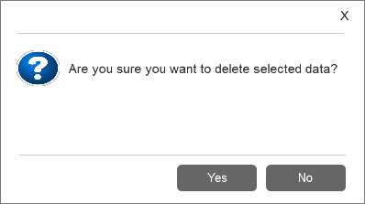

System behaviors:

* If ***Yes*** action is selected, system will deactivate selected data. Notes: data is deactivated instead of deleted/removed from database, to prevent error when viewing old forms that using the data.
* If ***No*** action is selected, system will stay remain on the List.

1. Ensure removing member from a group will not delete the information regarding workflow histories.
2. Removed member can still be added again in the same group.

View User in a Group

When a row data is selected and clicked, system will display a form as follow:

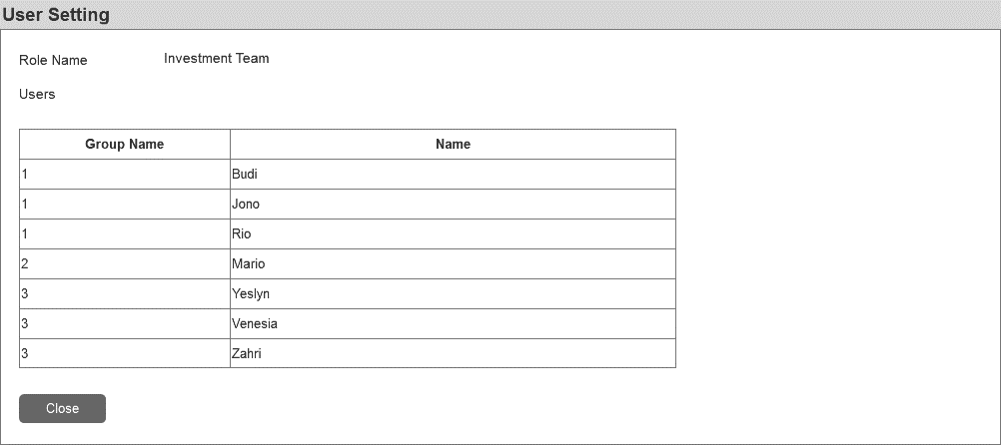

|  |  |  |  |  |
| --- | --- | --- | --- | --- |
| Field Name | Field Type (length) | Mandatory? | Default Value | Remarks |
| Role Name | Label | - | Display selected data |  |
| Users | Table | - | Display selected data |  |
| Close | Button | - | - | To close the view page. |

# Part III – Historical Financial & Financial Projection

**Historical Financial & Financial Projection**

## Facility

Facility is used to register facility data that will be displayed in the form as the value of dropdown list.

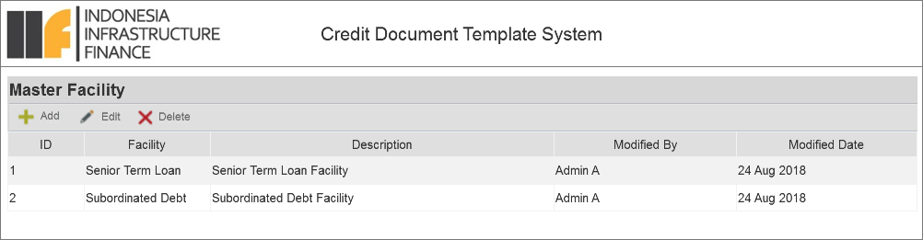

|  |  |  |  |  |
| --- | --- | --- | --- | --- |
| Field Name | Field Type (length) | Mandatory? | Default Value | Remarks |
| Add | Link button | - | - | To display add data form. |
| Edit | Link button | - | - | To display edit data form. |
| Delete | Link button | - | - | To display delete confirmation dialog (refer to 11.1.3). |
| Table | Table | - | Top 10 data based on last modified date with DESC order). | To display all facility data in the table. |

### Add Facility Data

When ***Add*** button is clicked, system will display a form as follow:

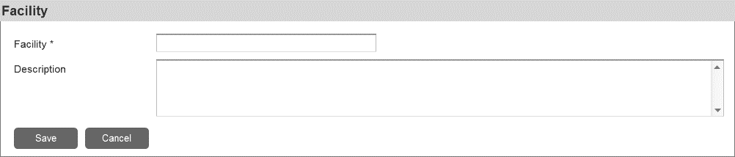

|  |  |  |  |  |
| --- | --- | --- | --- | --- |
| Field Name | Field Type (length) | Mandatory? | Default Value | Remarks |
| Facility | Textbox (50) | Yes | Blank | To input facility data. |
| Description | Text area (100) | No | Blank | To input the description of the data. |
| Save | Button | - | - | To display the save data confirmation dialog (refer to 11.1.1) and if ***Yes*** action is selected, system will run the validation rules. If the data has passed the rules, it will be saved in the system and another success alert will be displayed (refer to 11.2). Otherwise, system will display an error message (refer to 11.3). And if ***No*** action is selected, system will stay remain in the form page. |
| Cancel | Button | - | - | To display a discard data confirmation dialog (refer to 11.1.2). If ***Yes*** action is selected,system will discard data on the screen without saving them then close the form page (back to the Master Facility List). And if ***No*** action is selected, system will stay remain in the form page. |

Validation rules:

1. Mandatory fields should not be empty.
2. Check existing data (active data) to avoid data duplication.
3. If the value of new added data is same with the value of removed data (inactive data), this data will be treated as new data and able to be stored in the system.
4. Check size (length) of characters input by user.

### Edit Facility Data

When a data is selected and ***Edit*** button is clicked, system will display a form as follow:

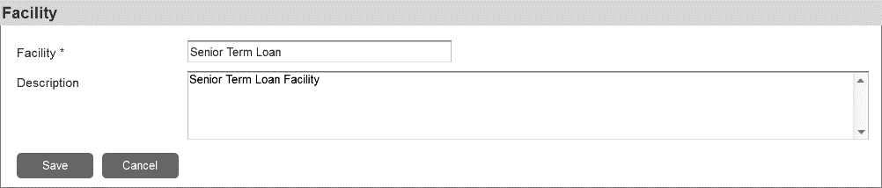

|  |  |  |  |  |
| --- | --- | --- | --- | --- |
| Field Name | Field Type (length) | Mandatory? | Default Value | Remarks |
| Facility | Textbox (50) | Yes | Existing selected data | To edit existing facility data. |
| Description | Text area (100) | No | Existing selected data | To edit existing facility data. |
| Save | Button | - | - | To display the save data confirmation dialog (refer to 11.1.1) and if ***Yes*** action is selected, system will run the validation rules. If the data has passed the rules, it will be saved in the system and another success alert will be displayed (refer to 11.2). Otherwise, system will display an error message (refer to 11.3). And if ***No*** action is selected, system will stay remain in the form page. |
| Cancel | Button | - | - | To display a discard data confirmation dialog (refer to 11.1.2). If ***Yes*** action is selected,system will discard all changes made on the screen without saving them then close the form page (back to the Master Facility List). And if ***No*** action is selected, system will stay remain in the form page. |

Validation rules:

1. Mandatory fields should not be empty.
2. Check existing data to avoid data duplication.
3. If the value of edited data is same with the value of removed data (inactive data), this data will be treated as new data and able to be stored in the system.
4. Check size (length) of characters input by user.

### Delete Facility Data

When one or more data is selected and ***Delete*** button is clicked, system will display a confirmation as follow (refer to 11.1.3):



System behaviors:

* If ***Yes*** action is selected, system will deactivate selected data. Notes: data is deactivated instead of deleted/removed from database, to prevent error when viewing old forms that using the data.
* If ***No*** action is selected, system will stay remain on the Master Facility List.

# Part IV – Supplemental, Procurement and Insurance

**Supplemental, Procurement and Insurance**

## Product Type

Product Type is used to register product type data that will be displayed in the form as the value of dropdown list.

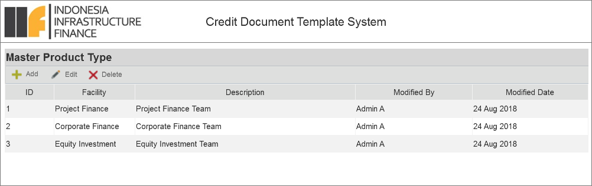

|  |  |  |  |  |
| --- | --- | --- | --- | --- |
| Field Name | Field Type (length) | Mandatory? | Default Value | Remarks |
| Add | Link button | - | - | To display add data form. |
| Edit | Link button | - | - | To display edit data form. |
| Delete | Link button | - | - | To display delete confirmation dialog (refer to 11.1.3). |
| Table | Table | - | Top 10 data based on last modified date with DESC order). | To display all product type data in the table. |

### Add Product Type Data

When ***Add*** button is clicked, system will display a form as follow:

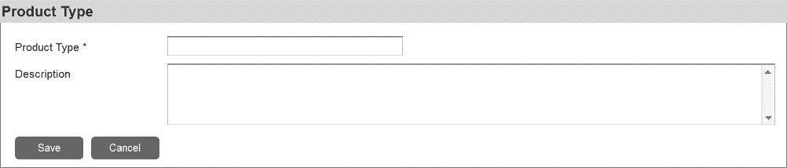

|  |  |  |  |  |
| --- | --- | --- | --- | --- |
| Field Name | Field Type (length) | Mandatory? | Default Value | Remarks |
| Product Type | Textbox (50) | Yes | Blank | To input product type data. |
| Description | Text area (100) | No | Blank | To input the description of the data. |
| Save | Button | - | - | To display the save data confirmation dialog (refer to 11.1.1) and if ***Yes*** action is selected, system will run the validation rules. If the data has passed the rules, it will be saved in the system and another success alert will be displayed (refer to 11.2). Otherwise, system will display an error message (refer to 11.3). And if ***No*** action is selected, system will stay remain in the form page. |
| Cancel | Button | - | - | To display a discard data confirmation dialog (refer to 11.1.2). If ***Yes*** action is selected,system will discard data on the screen without saving them then close the form page (back to the Master Product Type List). And if ***No*** action is selected, system will stay remain in the form page. |

Validation rules:

1. Mandatory fields should not be empty.
2. Check existing data to avoid data duplication.
3. If the value of new added data is same with the value of removed data (inactive data), this data will be treated as new data and able to be stored in the system.
4. Check size (length) of characters input by user.

### Edit Product Type Data

When a data is selected and ***Edit*** button is clicked, system will display a form as follow:

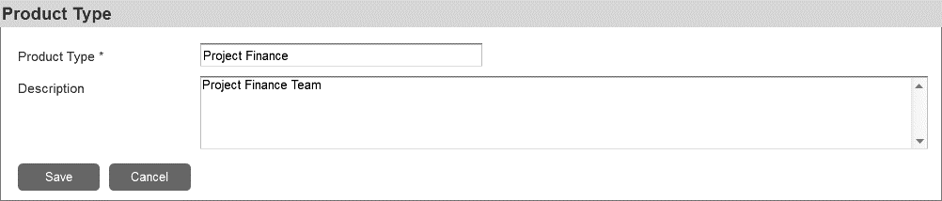

|  |  |  |  |  |
| --- | --- | --- | --- | --- |
| Field Name | Field Type (length) | Mandatory? | Default Value | Remarks |
| Product Type | Textbox (50) | Yes | Existing selected data | To edit existing currency data. |
| Description | Text area (100) | No | Existing selected data | To edit existing currency data. |
| Save | Button | - | - | To display the save data confirmation dialog (refer to 11.1.1) and if ***Yes*** action is selected, system will run the validation rules. If the data has passed the rules, it will be saved in the system and another success alert will be displayed (refer to 11.2). Otherwise, system will display an error message (refer to 11.3). And if ***No*** action is selected, system will stay remain in the form page. |
| Cancel | Button | - | - | To display a discard data confirmation dialog (refer to 11.1.2). If ***Yes*** action is selected,system will discard all changes made on the screen without saving them then close the form page (back to the Master Product Type List). And if ***No*** action is selected, system will stay remain in the form page. |

Validation rules:

1. Mandatory fields should not be empty.
2. Check existing data to avoid data duplication.
3. If the value of edited data is same with the value of removed data (inactive data), this data will be treated as new data and able to be stored in the system.
4. Check size (length) of characters input by user.

### Delete Product Type Data

When one or more data is selected and ***Delete*** button is clicked, system will display a confirmation as follow (refer to 11.1.3):



System behaviors:

* If ***Yes*** action is selected, system will deactivate selected data. Notes: data is deactivated instead of deleted/removed from database, to prevent error when viewing old forms that using the data.
* If ***No*** action is selected, system will stay remain on the Master Product Type List.

# Part V – Social and Environmental Assessment/IIF’s Principles

**Social and Environmental Assessment/ IIF’s Principles**

## Master Currency

Currency is used to register currency data that will be displayed in the form as the value of dropdown list.

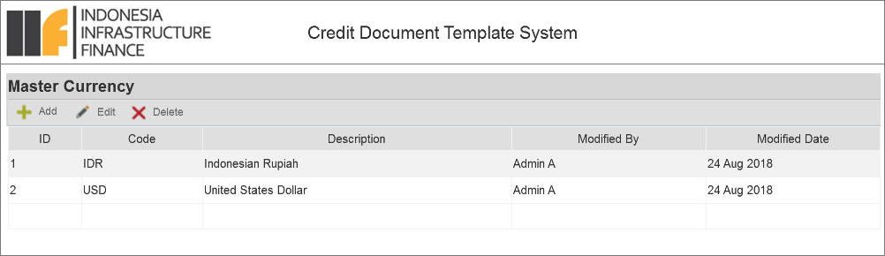

|  |  |  |  |  |
| --- | --- | --- | --- | --- |
| Field Name | Field Type (length) | Mandatory? | Default Value | Remarks |
| Add | Link button | - | - | To display add data form. |
| Edit | Link button | - | - | To display edit data form. |
| Delete | Link button | - | - | To display delete confirmation dialog (refer to 11.1.3). |
| Table | Table | - | Top 10 data based on last modified date with DESC order). | To display all currency data in the table. |

### Add Currency Data

When ***Add*** button is clicked, system will display a form as follow:

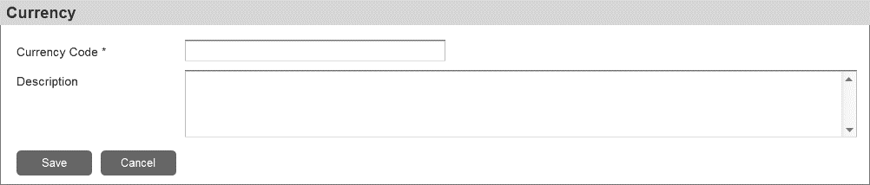

|  |  |  |  |  |
| --- | --- | --- | --- | --- |
| Field Name | Field Type (length) | Mandatory? | Default Value | Remarks |
| Currency | Textbox (5) | Yes | Blank | To input currency data. |
| Description | Text area (100) | No | Blank | To input the description of the data. |
| Save | Button | - | - | To display the save data confirmation dialog (refer to 11.1.1) and if ***Yes*** action is selected, system will run the validation rules. If the data has passed the rules, it will be saved in the system and another success alert will be displayed (refer to 11.2). Otherwise, system will display an error message (refer to 11.3). And if ***No*** action is selected, system will stay remain in the form page. |
| Cancel | Button | - | - | To display a discard data confirmation dialog (refer to 11.1.2). If ***Yes*** action is selected,system will discard data on the screen without saving them then close the form page (back to the Master Currency List). And if ***No*** action is selected, system will stay remain in the form page. |

Validation rules:

1. Mandatory fields should not be empty.
2. Check existing data to avoid data duplication.
3. If the value of new added data is same with the value of removed data (inactive data), this data will be treated as new data and able to be stored in the system.
4. Check size (length) of characters input by user.

### Edit Currency Data

When a data is selected and ***Edit*** button is clicked, system will display a form as follow:

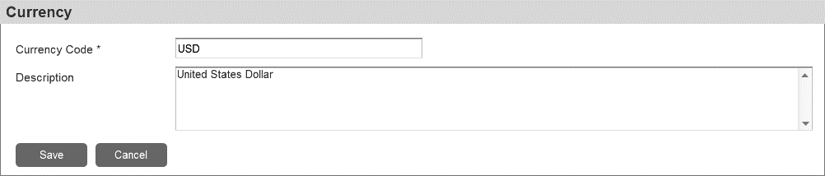

|  |  |  |  |  |
| --- | --- | --- | --- | --- |
| Field Name | Field Type (length) | Mandatory? | Default Value | Remarks |
| Currency | Textbox (5) | Yes | Existing selected data | To edit existing currency data. |
| Description | Text area (100) | No | Existing selected data | To edit existing currency data. |
| Save | Button | - | - | To display the save data confirmation dialog (refer to 11.1.1) and if ***Yes*** action is selected, system will run the validation rules. If the data has passed the rules, it will be saved in the system and another success alert will be displayed (refer to 11.2). Otherwise, system will display an error message (refer to 11.3). And if ***No*** action is selected, system will stay remain in the form page. |
| Cancel | Button | - | - | To display a discard data confirmation dialog (refer to 11.1.2). If ***Yes*** action is selected,system will discard all changes made on the screen without saving them then close the form page (back to the Master Currency List). And if ***No*** action is selected, system will stay remain in the form page. |

Validation rules:

1. Mandatory fields should not be empty.
2. Check existing data to avoid data duplication.
3. If the value of edited data is same with the value of removed data (inactive data), this data will be treated as new data and able to be stored in the system.
4. Check size (length) of characters input by user.

### Delete Currency Data

When one or more data is selected and ***Delete*** button is clicked, system will display a confirmation as follow (refer to 11.1.3):



System behaviors:

* If ***Yes*** action is selected, system will deactivate selected data. Notes: data is deactivated instead of deleted/removed from database, to prevent error when viewing old forms that using the data.
* If ***No*** action is selected, system will stay remain on the Master Currency List.

# Part VI - Attachment

## Group Structure

## TAT Report – PAM per Person

This report will contain TAT PICs who involved in an approved PAM.

Report Filter:

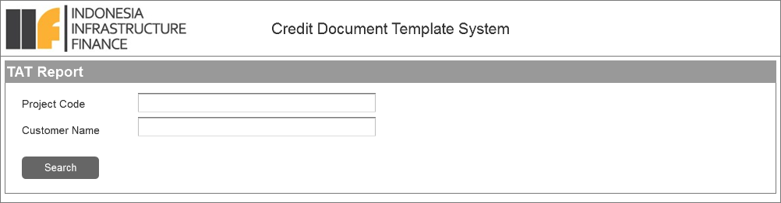

|  |  |  |  |  |
| --- | --- | --- | --- | --- |
| Field Name | Field Type (length) | Mandatory? | Default Value | Remarks |
| Project Code | Textbox (20) | Yes | Blank | To input project code. |
| Customer Name | Textbox (50) | No | Blank | To input client name. |
| Search | Button | - | - | To execute the data searching process. If the search criteria is empty, system will display an alert message (refer to 11.3). |

Report Result:

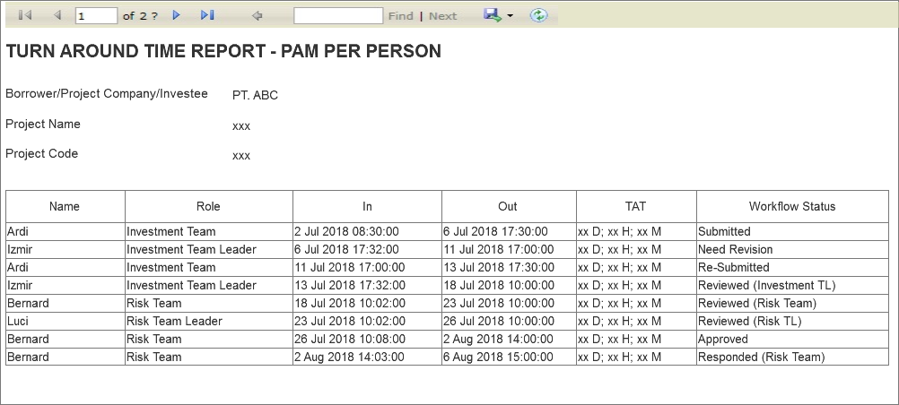

## Term Sheet

**Term Sheet**

## Public Holiday

Public Holiday is used to register public holiday data that will be used to count the TAT of workflow performers.

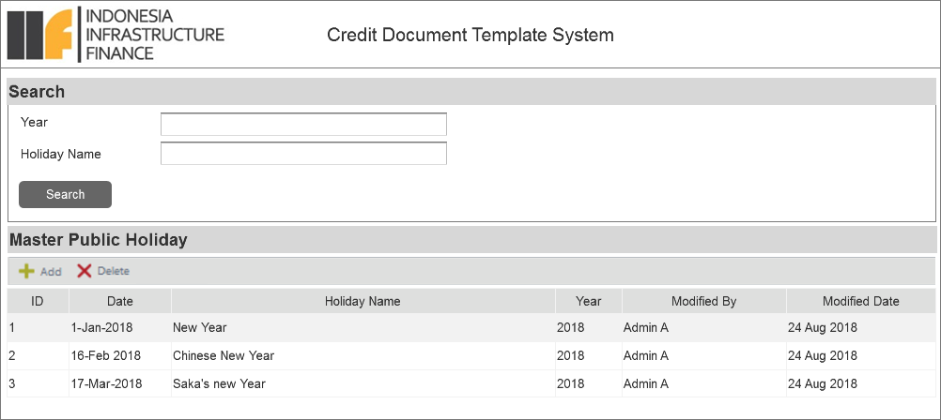

|  |  |  |  |  |
| --- | --- | --- | --- | --- |
| Field Name | Field Type (length) | Mandatory? | Default Value | Remarks |
| Year | Textbox (4) | Yes | Current Year | To input year (numeric only). |
| Holiday Name | Textbox (50) | No | Blank | To input name of holiday. |
| Search | Button | - | - | To execute the data filtering process. |
| Add | Link button | - | - | To display add data form. |
| Delete | Link button | - | - | To display delete confirmation dialog (refer to 11.1.3). |
| Table | Table | - | Blank | To display search result from Search action. |

Validation rules:

1. Textbox “Year” only accept numerical input.
2. When the ***Search*** button is clicked but the values of “Year” and “Holiday Name” are empty, system will display an error message (refer to 11.3.2 ).
3. Check size (length) of characters input by user.

### Add Public Holiday Data

When ***Add*** button is clicked, system will display a form as follow:

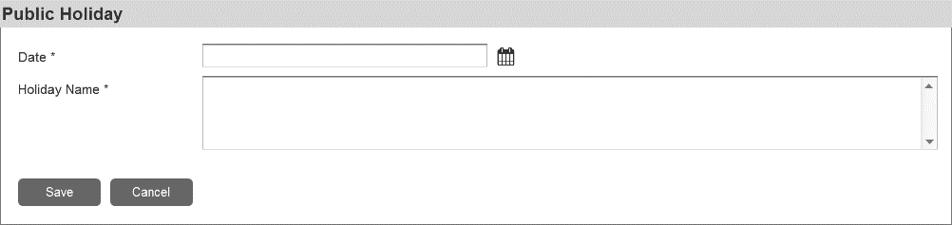

|  |  |  |  |  |
| --- | --- | --- | --- | --- |
| Field Name | Field Type (length) | Mandatory? | Default Value | Remarks |
| Date | Calendar | Yes | Blank | To input date of holiday. Format date shown in the user interface: DD-mmm-YYYY. |
| Holiday Name | Text area (100) | Yes | Blank | To input the description of the data. |
| Save | Button | - | - | To display the save data confirmation dialog (refer to 11.1.1) and if ***Yes*** action is selected, system will run the validation rules. If the data has passed the rules, it will be saved in the system and another success alert will be displayed (refer to 11.2). Otherwise, system will display an error message (refer to 11.3). And if ***No*** action is selected, system will stay remain in the form page. |
| Cancel | Button | - | - | To display a discard data confirmation dialog (refer to 11.1.2). If ***Yes*** action is selected,system will discard data on the screen without saving them then close the form page (back to the Master Public Holiday List). And if ***No*** action is selected, system will stay remain in the form page. |

Validation rules:

1. Mandatory fields should not be empty.
2. Check existing data to avoid data duplication.
3. If the value of new added data is same with the value of removed data (inactive data), this data will be treated as new data and able to be stored in the system.
4. Check size (length) of characters input by user.

### Delete Public Holiday Data

When one or more data is selected and ***Delete*** button is clicked, system will display a confirmation as follow (refer to 11.1.3):



System behaviors:

* If ***Yes*** action is selected, system will deactivate selected data. Notes: data is deactivated instead of deleted/removed from database, to prevent error when viewing old forms that using the data.
* If ***No*** action is selected, system will stay remain on the Master Public Holiday List.

## Risk rating

**Risk Rating**

## Master IIF Rating

IIF Rating is used to register IIF rating data that will be displayed in the form as the value of dropdown list.

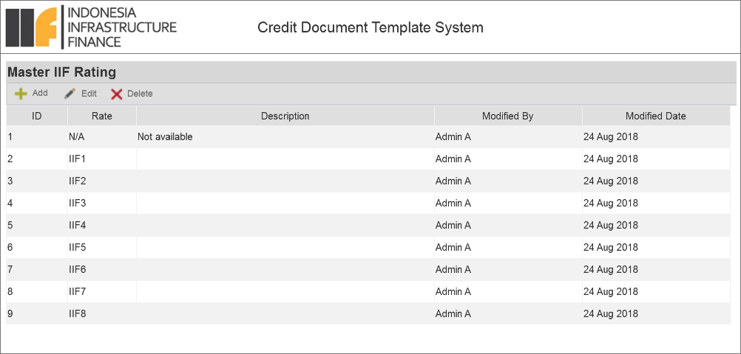

|  |  |  |  |  |
| --- | --- | --- | --- | --- |
| Field Name | Field Type (length) | Mandatory? | Default Value | Remarks |
| Add | Link button | - | - | To display add data form. |
| Edit | Link button | - | - | To display edit data form. |
| Delete | Link button | - | - | To display delete confirmation dialog (refer to 11.1.3). |
| Table | Table | - | Top 10 data based on last modified date with DESC order). | To display all IIF rating data in the table. |

### Add IIF Rating Data

When ***Add*** button is clicked, system will display a form as follow:

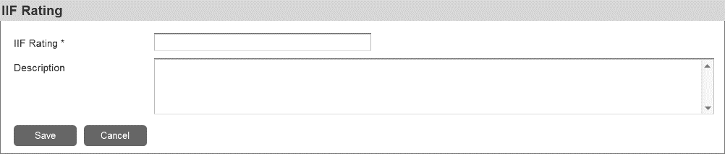

|  |  |  |  |  |
| --- | --- | --- | --- | --- |
| Field Name | Field Type (length) | Mandatory? | Default Value | Remarks |
| IIF Rating | Textbox (5) | Yes | Blank | To input IIF Rating data. |
| Description | Text area (500) | No | Blank | To input the description of the data. |
| Save | Button | - | - | To display the save data confirmation dialog (refer to 11.1.1) and if ***Yes*** action is selected, system will run the validation rules. If the data has passed the rules, it will be saved in the system and another success alert will be displayed (refer to 11.2). Otherwise, system will display an error message (refer to 11.3). And if ***No*** action is selected, system will stay remain in the form page. |
| Cancel | Button | - | - | To display a discard data confirmation dialog (refer to 11.1.2). If ***Yes*** action is selected,system will discard data on the screen without saving them then close the form page (back to the Master IIF Rating List). And if ***No*** action is selected, system will stay remain in the form page. |

Validation rules:

1. Mandatory fields should not be empty.
2. Check existing data to avoid data duplication.
3. If the value of new added data is same with the value of removed data (inactive data), this data will be treated as new data and able to be stored in the system.
4. Check size (length) of characters input by user.

### Edit IIF Rating Data

When a data is selected and ***Edit*** button is clicked, system will display a form as follow:

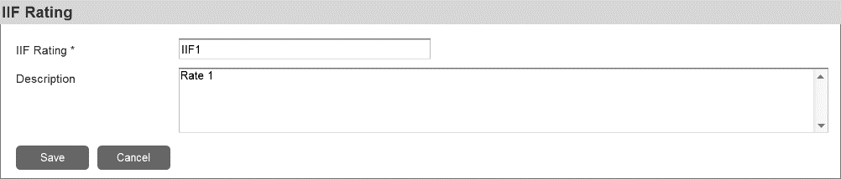

|  |  |  |  |  |
| --- | --- | --- | --- | --- |
| Field Name | Field Type (length) | Mandatory? | Default Value | Remarks |
| IIF Rating | Textbox (5) | Yes | Existing selected data | To edit existing IIF Rating data. |
| Description | Text area (500) | No | Existing selected data | To edit existing IIF Rating data. |
| Save | Button | - | - | To display the save data confirmation dialog (refer to 11.1.1) and if ***Yes*** action is selected, system will run the validation rules. If the data has passed the rules, it will be saved in the system and another success alert will be displayed (refer to 11.2). Otherwise, system will display an error message (refer to 11.3). And if ***No*** action is selected, system will stay remain in the form page. |
| Cancel | Button | - | - | To display a discard data confirmation dialog (refer to 11.1.2). If ***Yes*** action is selected,system will discard all changes made on the screen without saving them then close the form page (back to the Master IIF Rating List). And if ***No*** action is selected, system will stay remain in the form page. |

Validation rules:

1. Mandatory fields should not be empty.
2. Check existing data to avoid data duplication.
3. If the value of edited data is same with the value of removed data (inactive data), this data will be treated as new data and able to be stored in the system.
4. Check size (length) of characters input by user.

### Delete IIF Rating Data

When one or more data is selected and ***Delete*** button is clicked, system will display a confirmation as follow (refer to 11.1.3):



System behaviors:

* If ***Yes*** action is selected, system will deactivate selected data. Notes: data is deactivated instead of deleted/removed from database, to prevent error when viewing old forms that using the data.
* If ***No*** action is selected, system will stay remain on the Master IIF Rating List.

## KYC Checklists

**KYC Checklists**

## Master S&P Rating

S&P Rating is used to register S&P rating data that will be displayed in the form as the value of dropdown list.

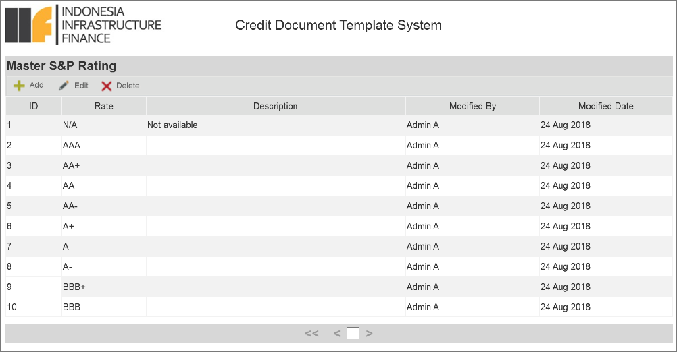

|  |  |  |  |  |
| --- | --- | --- | --- | --- |
| Field Name | Field Type (length) | Mandatory? | Default Value | Remarks |
| Add | Link button | - | - | To display add data form. |
| Edit | Link button | - | - | To display edit data form. |
| Delete | Link button | - | - | To display delete confirmation dialog (refer to 11.1.3). |
| Table | Table | - | Top 10 data based on last modified date with DESC order). | To display all S&P rating data in the table. |

### Add S&P Rating Data

When ***Add*** button is clicked, system will display a form as follow:

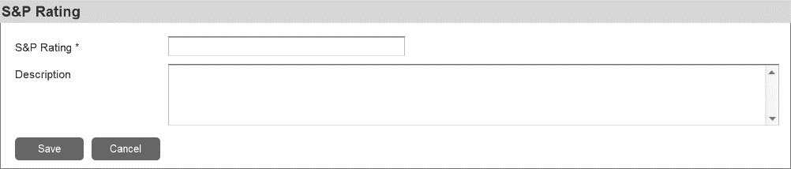

|  |  |  |  |  |
| --- | --- | --- | --- | --- |
| Field Name | Field Type (length) | Mandatory? | Default Value | Remarks |
| S&P Rating | Textbox (10) | Yes | Blank | To input S&P Rating data. |
| Description | Text area (500) | No | Blank | To input the description of the data. |
| Save | Button | - | - | To display the save data confirmation dialog (refer to 11.1.1) and if ***Yes*** action is selected, system will run the validation rules. If the data has passed the rules, it will be saved in the system and another success alert will be displayed (refer to 11.2). Otherwise, system will display an error message (refer to 11.3). And if ***No*** action is selected, system will stay remain in the form page. |
| Cancel | Button | - | - | To display a discard data confirmation dialog (refer to 11.1.2). If ***Yes*** action is selected,system will discard data on the screen without saving them then close the form page (back to the Master S&P Rating List). And if ***No*** action is selected, system will stay remain in the form page. |

Validation rules:

1. Mandatory fields should not be empty.
2. Check existing data to avoid data duplication.
3. If the value of new added data is same with the value of removed data (inactive data), this data will be treated as new data and able to be stored in the system.
4. Check size (length) of characters input by user.

### Edit S&P Rating Data

When a data is selected and ***Edit*** button is clicked, system will display a form as follow:

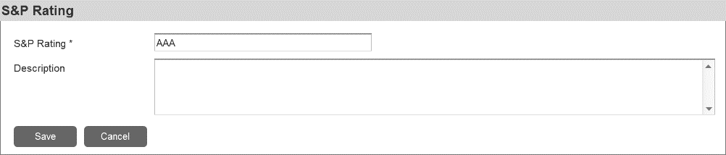

|  |  |  |  |  |
| --- | --- | --- | --- | --- |
| Field Name | Field Type (length) | Mandatory? | Default Value | Remarks |
| S&P Rating | Textbox (10) | Yes | Existing selected data | To edit existing S&P Rating data. |
| Description | Text area (500) | No | Existing selected data | To edit existing S&P Rating data. |
| Save | Button | - | - | To display the save data confirmation dialog (refer to 11.1.1) and if ***Yes*** action is selected, system will run the validation rules. If the data has passed the rules, it will be saved in the system and another success alert will be displayed (refer to 11.2). Otherwise, system will display an error message (refer to 11.3). And if ***No*** action is selected, system will stay remain in the form page. |
| Cancel | Button | - | - | To display a discard data confirmation dialog (refer to 11.1.2). If ***Yes*** action is selected,system will discard all changes made on the screen without saving them then close the form page (back to the Master S&P Rating List). And if ***No*** action is selected, system will stay remain in the form page. |

Validation rules:

1. Mandatory fields should not be empty.
2. Check existing data to avoid data duplication.
3. If the value of edited data is same with the value of removed data (inactive data), this data will be treated as new data and able to be stored in the system.
4. Check size (length) of characters input by user.

### Delete S&P Rating Data

When one or more data is selected and ***Delete*** button is clicked, system will display a confirmation as follow (refer to 11.1.3):



System behaviors:

* If ***Yes*** action is selected, system will deactivate selected data. Notes: data is deactivated instead of deleted/removed from database, to prevent error when viewing old forms that using the data.
* If ***No*** action is selected, system will stay remain on the Master S&P Rating List.

## Other Banks Facilities / Summary of Pefindo report

**Other Banks Facilities / Summary of Pefindo Report**

## Master Moody’s Rating

Moody’s Rating is used to register moody’s rating data that will be displayed in the form as the value of dropdown list.

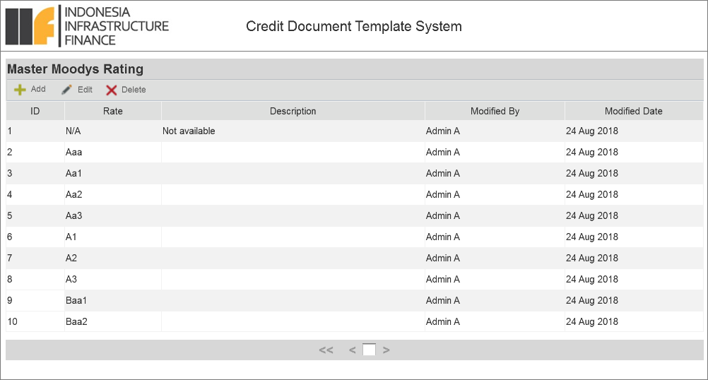

|  |  |  |  |  |
| --- | --- | --- | --- | --- |
| Field Name | Field Type (length) | Mandatory? | Default Value | Remarks |
| Add | Link button | - | - | To display add data form. |
| Edit | Link button | - | - | To display edit data form. |
| Delete | Link button | - | - | To display delete confirmation dialog (refer to 11.1.3). |
| Table | Table | - | Top 10 data based on last modified date with DESC order). | To display all Moody’s rating data in the table. |

### Add Moody’s Rating Data

When ***Add*** button is clicked, system will display a form as follow:

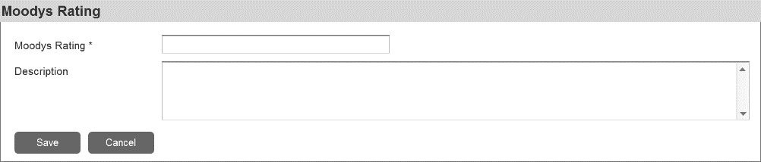

|  |  |  |  |  |
| --- | --- | --- | --- | --- |
| Field Name | Field Type (length) | Mandatory? | Default Value | Remarks |
| Moody’s Rating | Textbox (10) | Yes | Blank | To input Moody’s Rating data. |
| Description | Text area (500) | No | Blank | To input the description of the data. |
| Save | Button | - | - | To display the save data confirmation dialog (refer to 11.1.1) and if ***Yes*** action is selected, system will run the validation rules. If the data has passed the rules, it will be saved in the system and another success alert will be displayed (refer to 11.2). Otherwise, system will display an error message (refer to 11.3). And if ***No*** action is selected, system will stay remain in the form page. |
| Cancel | Button | - | - | To display a discard data confirmation dialog (refer to 11.1.2). If ***Yes*** action is selected,system will discard data on the screen without saving them then close the form page (back to the Master Moody’s Rating List). And if ***No*** action is selected, system will stay remain in the form page. |

Validation rules:

1. Mandatory fields should not be empty.
2. Check existing data to avoid data duplication.
3. If the value of new added data is same with the value of removed data (inactive data), this data will be treated as new data and able to be stored in the system.
4. Check size (length) of characters input by user.

### Edit Moody’s Rating Data

When a data is selected and ***Edit*** button is clicked, system will display a form as follow:

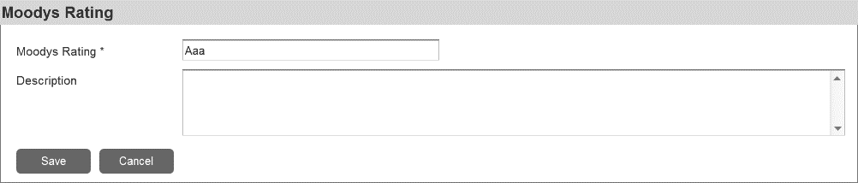

|  |  |  |  |  |
| --- | --- | --- | --- | --- |
| Field Name | Field Type (length) | Mandatory? | Default Value | Remarks |
| Moody’s Rating | Textbox (10) | Yes | Existing selected data | To edit existing Moody’s Rating data. |
| Description | Text area (500) | No | Existing selected data | To edit existing Moody’s Rating data. |
| Save | Button | - | - | To display the save data confirmation dialog (refer to 11.1.1) and if ***Yes*** action is selected, system will run the validation rules. If the data has passed the rules, it will be saved in the system and another success alert will be displayed (refer to 11.2). Otherwise, system will display an error message (refer to 11.3). And if ***No*** action is selected, system will stay remain in the form page. |
| Cancel | Button | - | - | To display a discard data confirmation dialog (refer to 11.1.2). If ***Yes*** action is selected,system will discard all changes made on the screen without saving them then close the form page (back to the Master Moody’s Rating List). And if ***No*** action is selected, system will stay remain in the form page. |

Validation rules:

1. Mandatory fields should not be empty.
2. Check existing data to avoid data duplication.
3. If the value of edited data is same with the value of removed data (inactive data), this data will be treated as new data and able to be stored in the system.
4. Check size (length) of characters input by user.

### Delete Moody’s Rating Data

When one or more data is selected and ***Delete*** button is clicked, system will display a confirmation as follow (refer to 11.1.3):



System behaviors:

* If ***Yes*** action is selected, system will deactivate selected data. Notes: data is deactivated instead of deleted/removed from database, to prevent error when viewing old forms that using the data.
* If ***No*** action is selected, system will stay remain on the Master Moody’s Rating List.

## Industry Analysis

## PAM Report

This report will contain information regarding approved PAM document (approved by BoD-IC).

Report Filter:

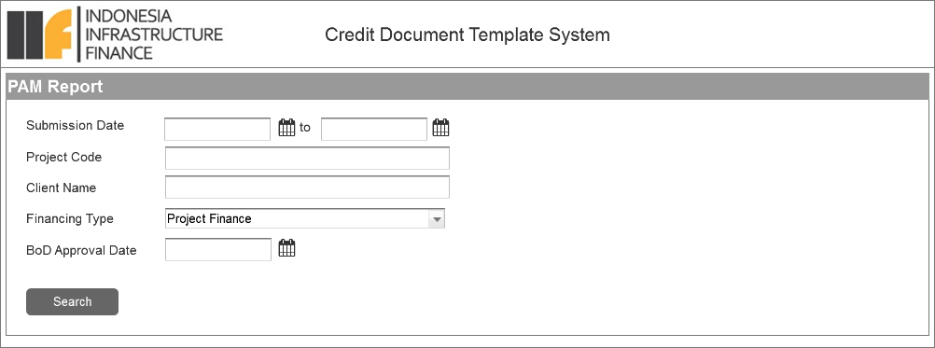

|  |  |  |  |  |
| --- | --- | --- | --- | --- |
| Field Name | Field Type (length) | Mandatory? | Default Value | Remarks |
| Submission Date (Start) | Calendar | No | Blank | To input submission date as start of period range. Format date shown in the user interface: DD-mmm-YYYY. |
| Submission Date (End) | Calendar | No | Blank | To input submission date as end of period range. Format date shown in the user interface: DD-mmm-YYYY. |
| Client Name | Textbox (50) | Yes | Blank | To input project company name/investee/borrower name. |
| Financing Type | Dropdown | No | - | To select type of finance product. The value of this dropdown will be taken from Master Product. |
| BoD Approval Date | Calendar | No | Blank | To input BoD’s approval date. Format date shown in the user interface: DD-mmm-YYYY. |
| Search | Button | - | - | To execute the data searching process. If the search criteria is empty, system will display an alert message (refer to 11.3). |

Report Result:

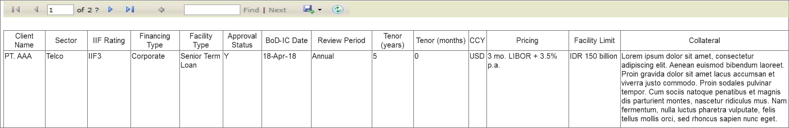

## Legal Due Diligence Report

|  |  |
| --- | --- |
| Attachment | Description |
| |  | | --- | | Legal Due.pdf | | |  | | --- | | Legal Due Diligence Report | |

## S&E Due Diligence

|  |  |
| --- | --- |
| Attachment | Description |
| |  | | --- | | S&amp;E Due Diligence.xlsx | | |  | | --- | | S&E Due Diligence | |

## Other Reports

|  |  |
| --- | --- |
| Attachment | Description |
| |  | | --- | | Other Reports.pptx | | |  | | --- | | Other Reports | |